Figma Wireframes

My Rationale
I went for a high-level minimalistic design. It’s clear and easy to understand. I chose the colour black because I think legal professionals won’t want any clutter and would like to get to the point

Homepage


Login
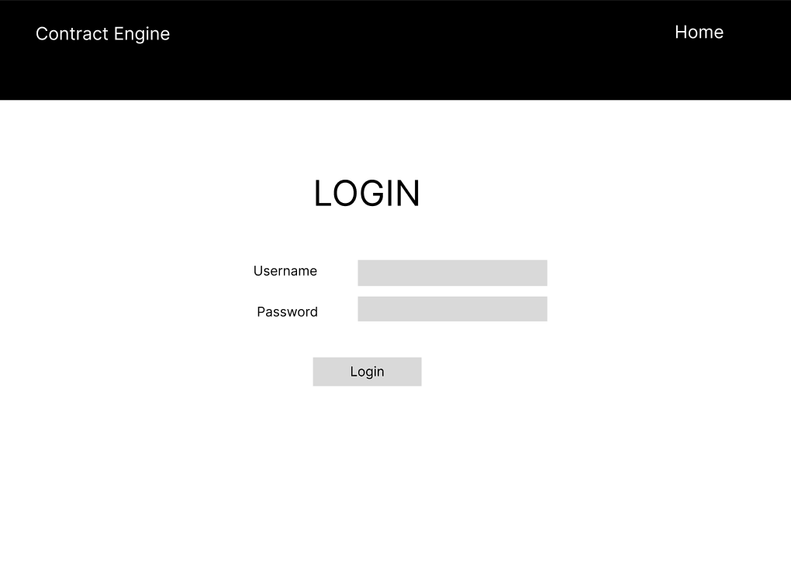
Dashboard
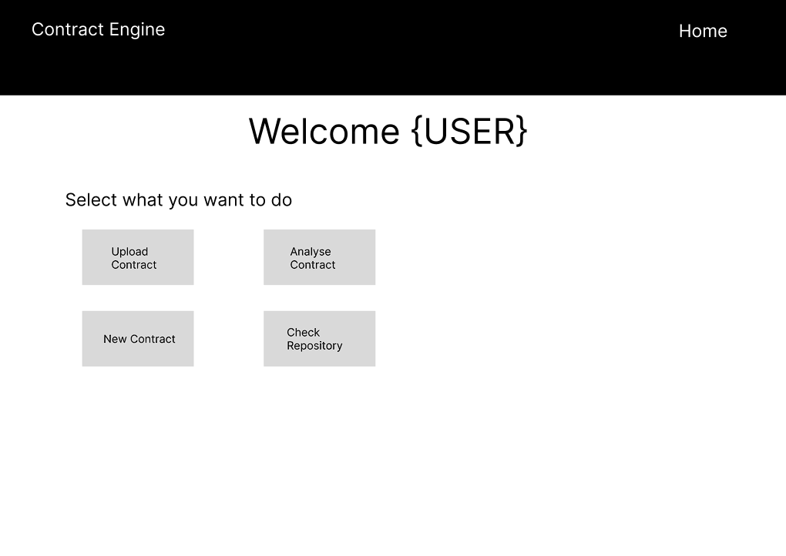

New Contract Generation
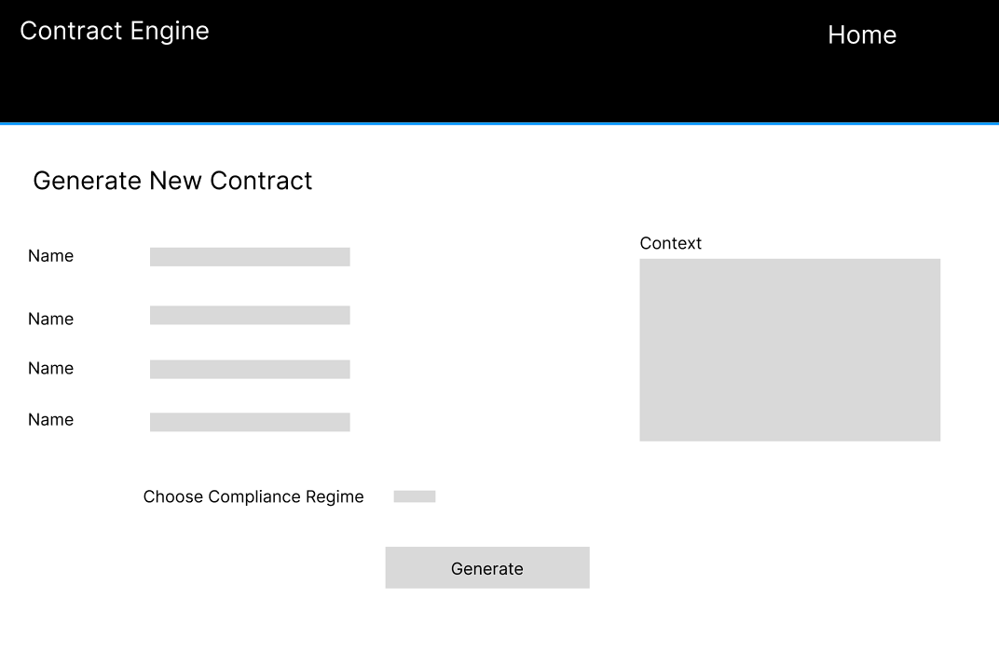
Contract Repository
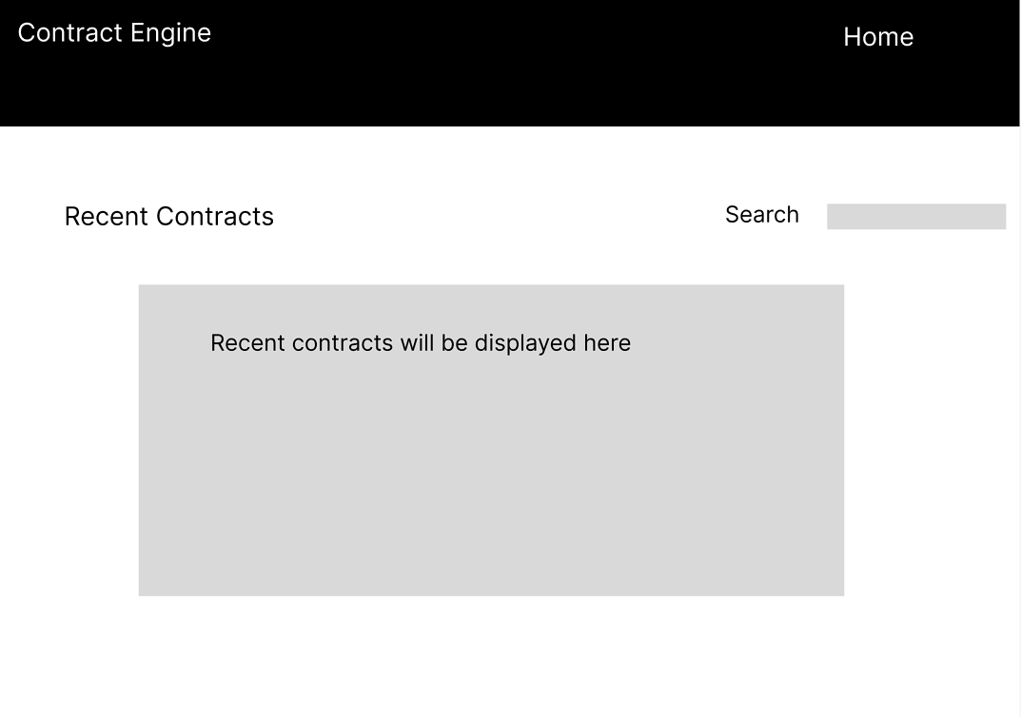
Analysis of Contracts
